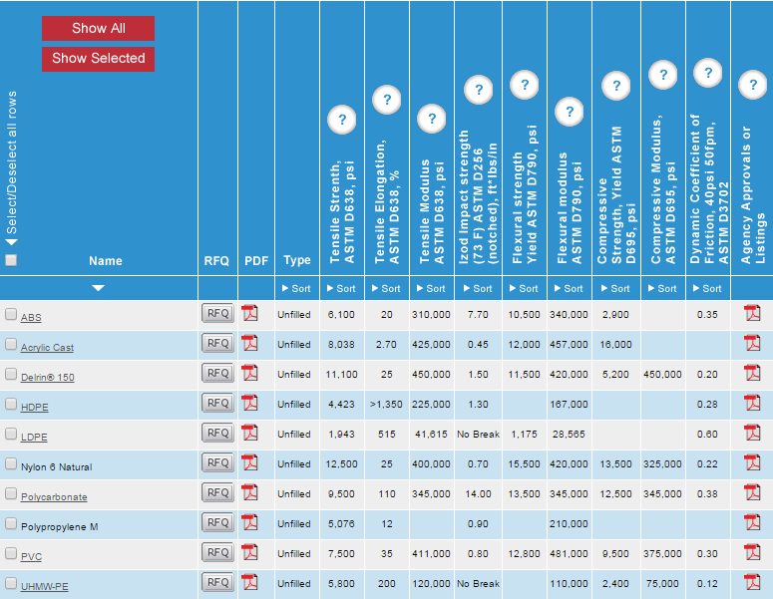

<http://www.plasticsintl.com/sortable_materials.php>

<http://www.plasticsintl.com/datasheets/Cast%20Nylon%20Nat%20MD.pdf>

<http://www.plasticsintl.com/datasheets/Delrin_150.pdf>

<http://plastics.dupont.com/plastics/pdflit/americas/design/DCI184.pdf>

<http://www.interstateplastics.com/materialspecs/web-acetal.pdf>

<http://www.interstateplastics.com/materialspecs/web-nylon.pdf>

<https://www.interstateplastics.com/Nylon-Natural-Cast-Rod-NYLNC.php?sku=NYLNC&vid=201509011530-5p&diameter=6.000&dim2=1>

<http://www.eplastics.com/Plastic/Nylon_Rod/NYLNATROD6-000>